ASSIGNMENT 19

PRANEESH SHARMA

B22

21052264

Q1. Write a program to display details of 2 books

Code:

//this program displays details of 2 books

#include <stdio.h>

struct book{

    char    author[30];

    int     pages;

    float   cost;

};

int main()

{

    struct book b1, b2;

    printf("\nEnter details for book 1\n");

    printf("Author Name :");

    gets(b1.author);

    printf("Number of Pages :");

    scanf("%d",&b1.pages);

    printf("Cost :");

scanf("%f",&b1.cost);

    printf("\nEnter details for book 2\n");

    printf("Author Name :");

    gets(b2.author);

    printf("Number of Pages :");

    scanf("%d",&b2.pages);

    printf("Cost :");

    scanf("%f",&b2.cost);

printf("\nEntered details are:");

    printf("\nAuthor Name: %s",b1.author);

    printf("\nNumber of pages: %d",b1.pages);

printf("\nCost: %.2f\n",b1.cost);

    printf("\nAuthor Name: %s",b2.author);

    printf("\nNumber of pages: %d",b2.pages);

printf("\nCost: %.2f\n",b2.cost);

    return 0;

}

Output:

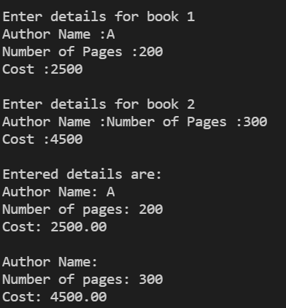

Q2. Write a program to display details and average salary of employees

Code:

//this program defines a structure of employee having data members name,number,age,salary and displays average salary

#include <stdio.h>

struct employee

{

    char name[20];

    int number, age;

    float salary;

};

int main()

{

    int n, i;

    float avg, sum=0;

    struct employee e[10];

    printf("Enter number of inputs: ");

scanf("%d", &n);

    for(i=0;i<n;i++)

    {

        printf("Enter name, number, age and salary of employee %d: ", i+1);

        scanf("%s %d %d %f", e[i].name, &e[i].number, &e[i].age, &e[i].salary);

    }

    for(i=0;i<n;i++)

    {

        printf("Name: %s", e[i].name);

        printf("\nNumber: %d", e[i].number);

        printf("\nAge: %d", e[i].age);

        printf("\nSalary: %.2f", e[i].salary);

        printf("\n");

    }

    for(i=0;i<n;i++)

    {

        sum += e[i].salary;

    }

    avg = sum/n;

    printf("Average Salary: %.2f", avg);

    return 0;

}

Output:

